Question 4:

|  |  |  |  |  |  |  |  |  |
| --- | --- | --- | --- | --- | --- | --- | --- | --- |
| p | q | r |  | p | v | (~q | ^ | r) |
| 0 | 0 | 0 |  | 0 | 0 | 1 | 0 | 0 |
| 0 | 0 | 1 |  | 0 | 1 | 1 | 1 | 1 |
| 0 | 1 | 0 |  | 0 | 0 | 0 | 0 | 0 |
| 0 | 1 | 1 |  | 0 | 0 | 0 | 0 | 1 |
| 1 | 0 | 0 |  | 1 | 1 | 1 | 0 | 0 |
| 1 | 0 | 1 |  | 1 | 1 | 1 | 1 | 1 |
| 1 | 1 | 0 |  | 1 | 1 | 0 | 0 | 0 |
| 1 | 1 | 1 |  | 1 | 1 | 0 | 0 | 1 |

|  |  |  |  |  |  |  |  |  |  |  |
| --- | --- | --- | --- | --- | --- | --- | --- | --- | --- | --- |
| p | q | r |  | (p | v | ~q) | ^ | (p | v | r) |
| 0 | 0 | 0 |  | 0 | 1 | 1 | 0 | 0 | 0 | 0 |
| 0 | 0 | 1 |  | 0 | 1 | 1 | 1 | 0 | 1 | 1 |
| 0 | 1 | 0 |  | 0 | 0 | 0 | 0 | 0 | 0 | 0 |
| 0 | 1 | 1 |  | 0 | 0 | 0 | 0 | 0 | 1 | 1 |
| 1 | 0 | 0 |  | 1 | 1 | 1 | 1 | 1 | 1 | 0 |
| 1 | 0 | 1 |  | 1 | 1 | 1 | 1 | 1 | 1 | 1 |
| 1 | 1 | 0 |  | 1 | 1 | 0 | 1 | 1 | 1 | 0 |
| 1 | 1 | 1 |  | 1 | 1 | 0 | 1 | 1 | 1 | 1 |

Question 6:

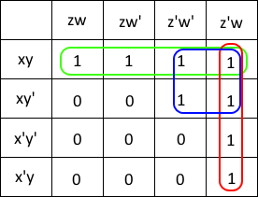

xy + xz’ + z’w

= x(y + z’)+ z’w

Question 11:

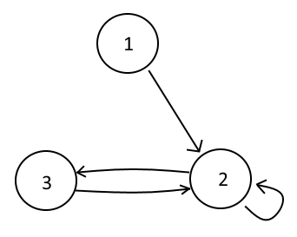

Question 14:

